

Bicol University

Bicol University College of Science

Hotel Management System

# **USERS MANUAL**

**Prepared by:**

Arjay A. Del ayre

BS Information Technology 3-A

**Submitted to:**

Dr. Michael Angelo D. Brogada

**GETTING STARTED**

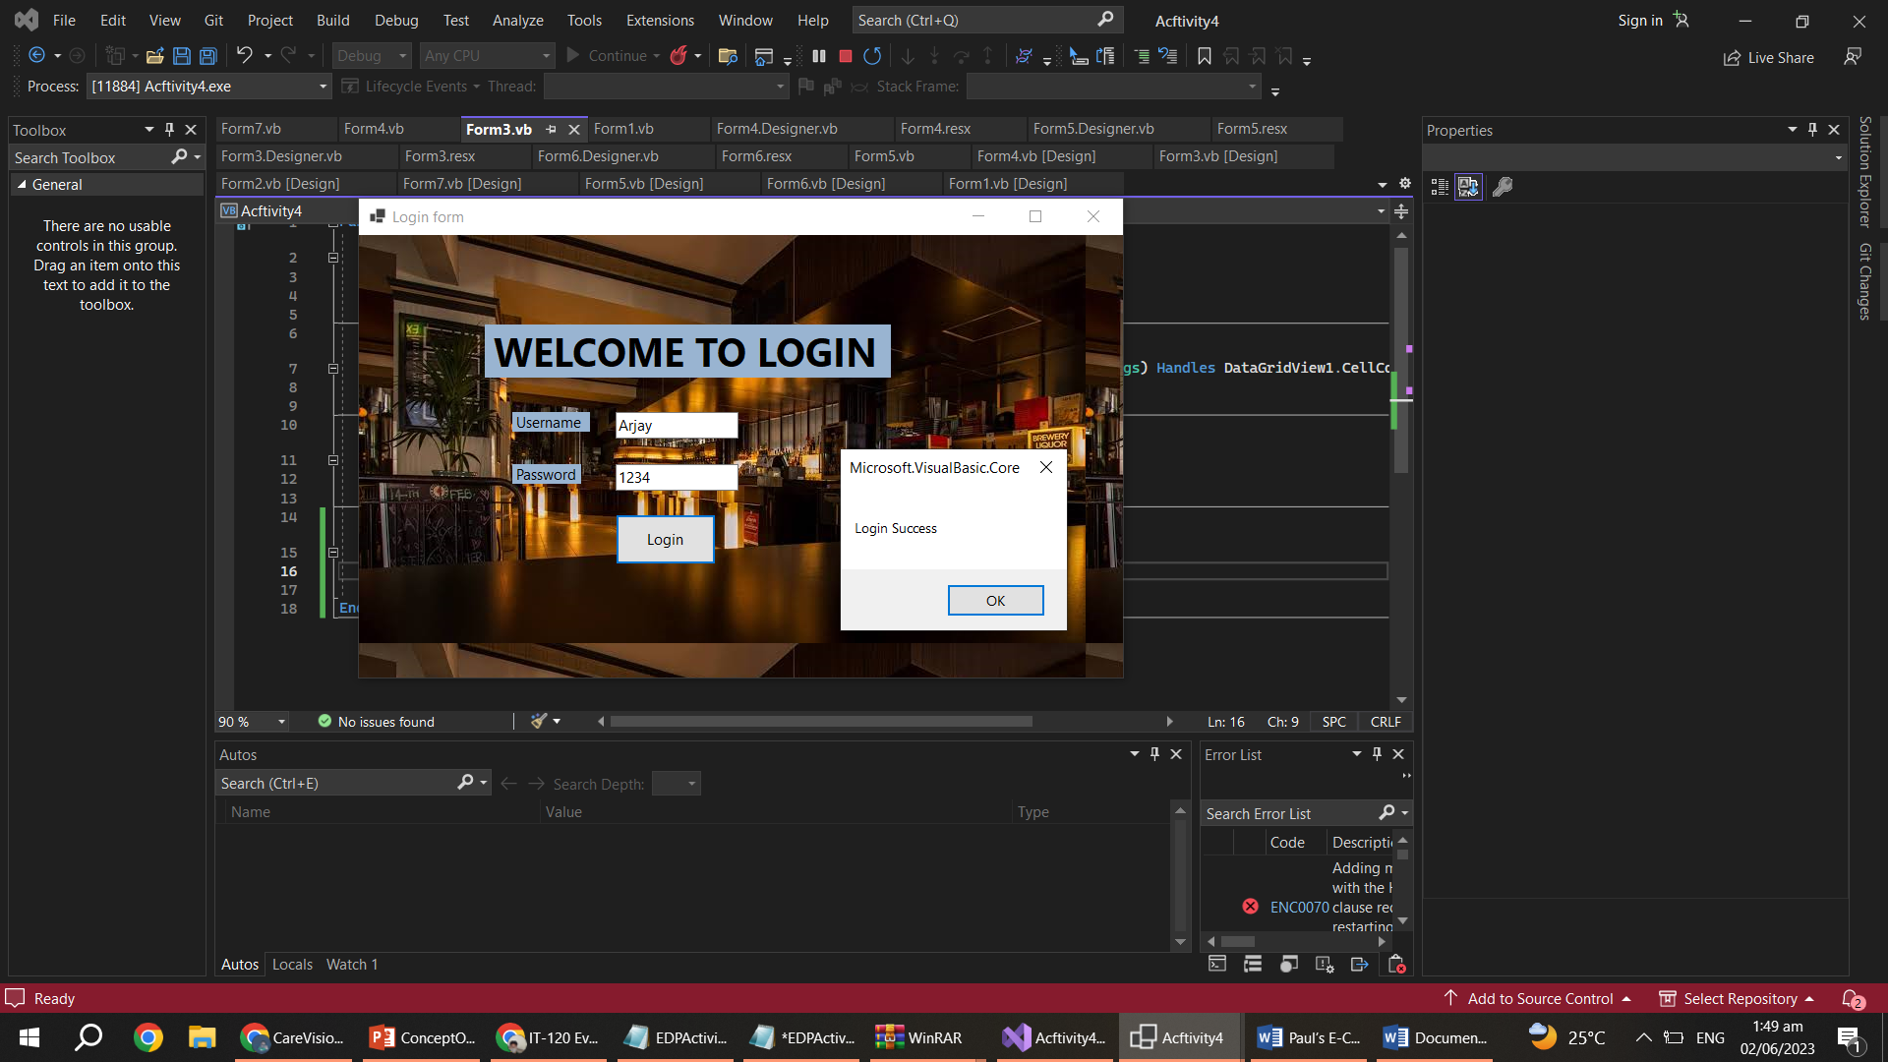

To begin using the Hotel Management System, you will first need to access the login page. Follow the steps below to get started:

1. Open the Hotel Management site
2. Enter your credentials the username and password.
3. Click on the "LOGIN” button to access the system.

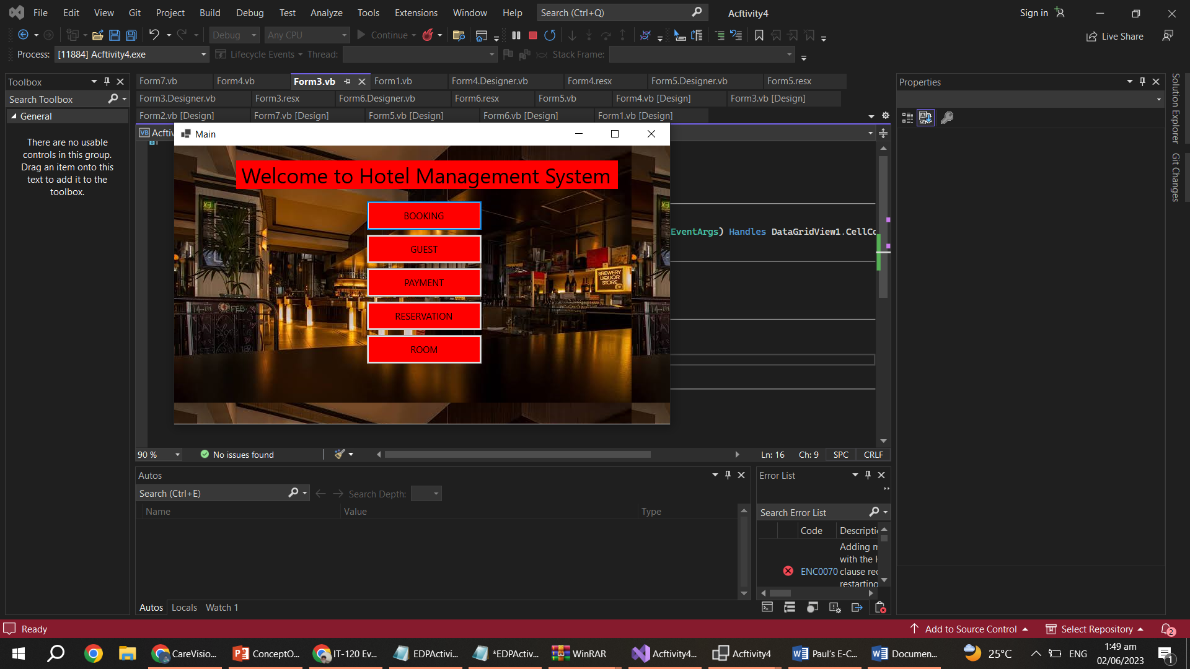

**DASHBOARD**

Upon logging into our hotel management system, you will see the dashboard, which serves as the central control for all your hotel administration needs. Think of it as a one-stop hub where you can access and manage various aspects of the hotel management system in a streamlined and efficient manner. The dashboard is designed to provide a comprehensive range of functionalities and features to meet your specific requirements. It acts as a command center, allowing you to efficiently manage and monitor all essential aspects of the hotel's operations.

By centralizing all these functionalities in one place, the dashboard eliminates the need for multiple systems or manual processes, saving you time and effort. You can perform tasks quickly and effectively, reducing administrative burdens and allowing you to focus on more critical aspects of the hotel management system. The dashboard allows you to manage booking, guest, payment, reservations, and room, among other features. It provides real-time information and analytics, helping you make informed decisions and optimize your hotel's performance.

**Booking Track**

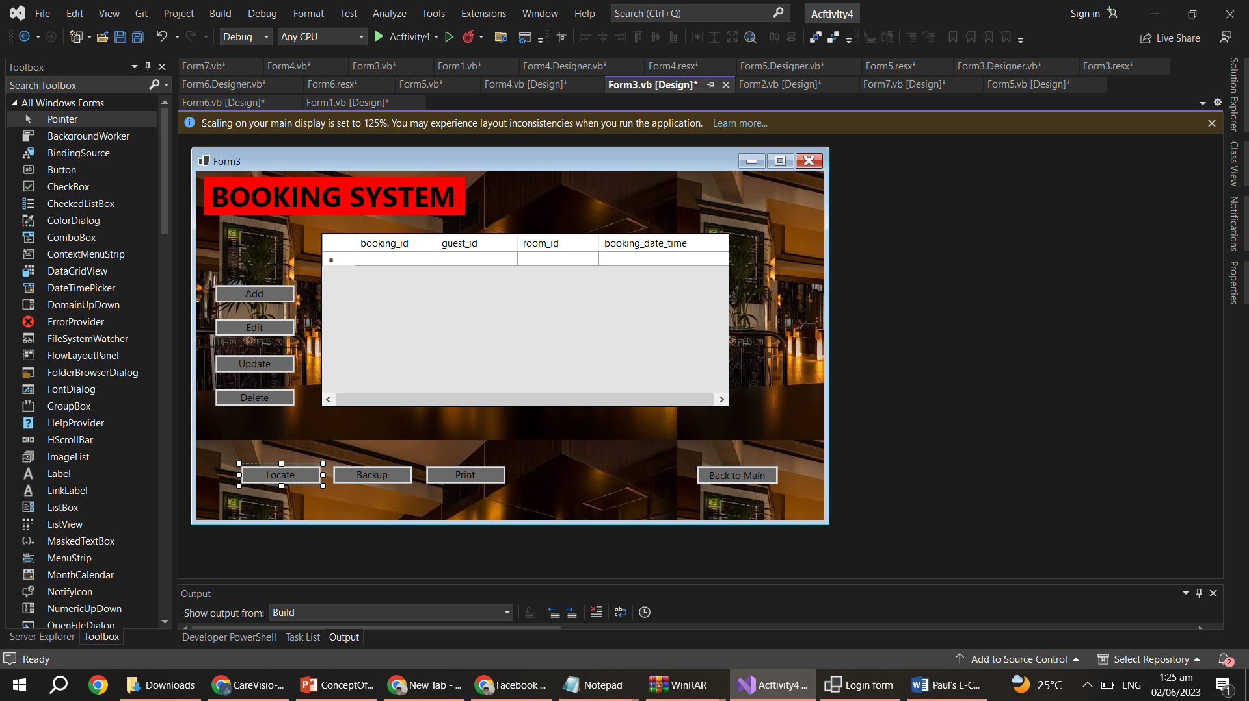

**Guest Track**

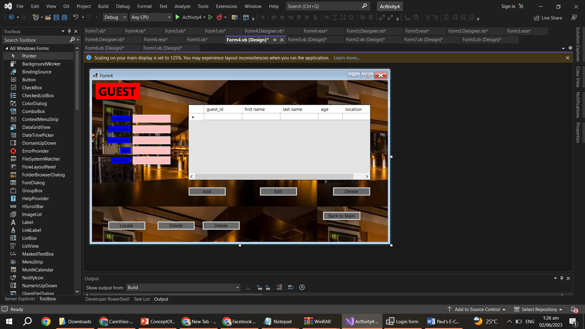

**Payment Track**

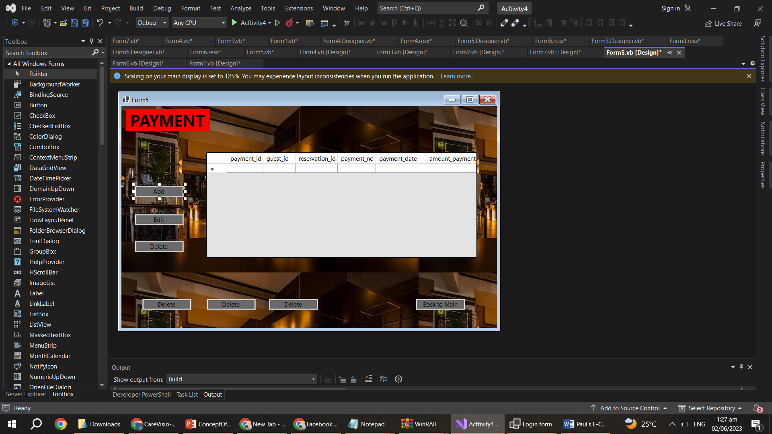

**Reservation Track**

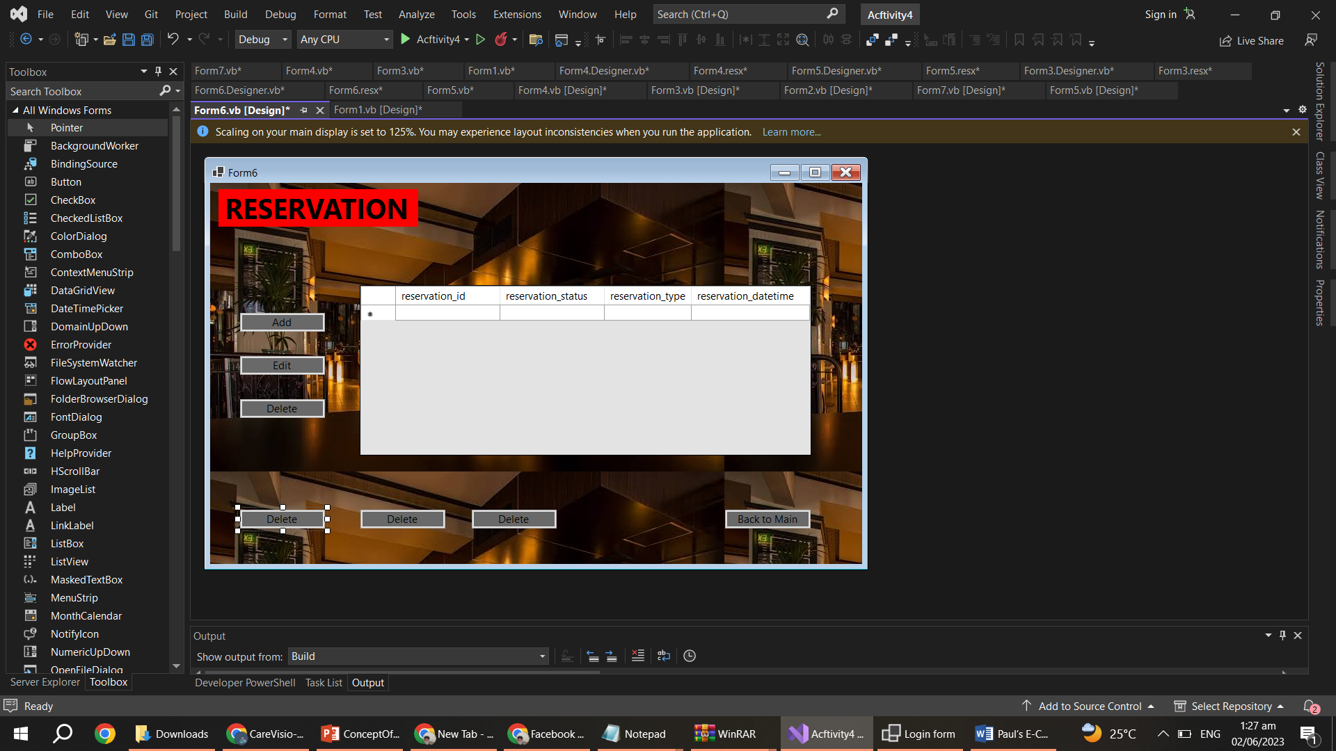

**Room Track**

